Installing JBoss Drools Plugin for Eclipse

Open Eclipse and select “Install New Software” from Window menu

Paste in the following URL where it says “Work with”
http://downloads.jboss.com/drools/updatesite3.4/

Click “Add…”

Wait until the screen refreshes to look like this:
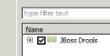

Click on the checkbox, then “Next” at the bottom of screen, giving you this:
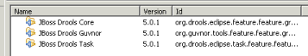

Click “Next” again, and you get the following screen:
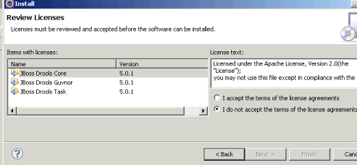

Click on “I accept the terms of the license agreements” and then click on “Finish”
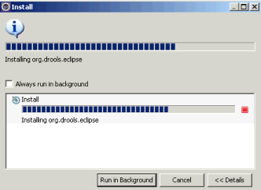

You will see a progress bar during the installation, and you may get the following warning, to which you should click “OK”
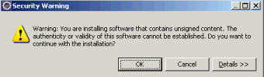

Finally, you will need to restart Eclipse:
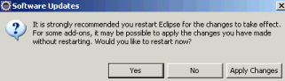

Restart Eclipse, and you should see that your Window / Preferences menu now shows the following
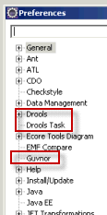

Open the Drools menu and click on “Installed Drools Runtimes”
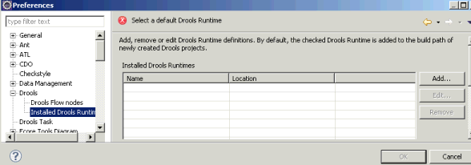

Click on the “Add…” button and

